Crime forecasting: a machine learning and computer vision approach to crime prediction

ABSTRACT

This paper offers a comprehensive analysis in computer vision approaches for crime predicting, with a particular emphasis on fingerprint detection. The Soko dataset, a comprehensive and varied set of fingerprints, is used in the study to create and assess a reliable crime prediction model. Utilizing computer vision technologies in conjunction with crime predicting, police enforcement tactics will be improved, and criminal activity will be prevented and resolved. In order to anticipate and address criminal activity in a proactive manner, crime forecasting is an essential component of contemporary law enforcement. Recent developments in computer vision technologies have created new opportunities to improve crime prediction and detection. Using the Soko Dataset, this paper provides a thorough review of fingerprint detection, utilising computer vision techniques to increase the precision and efficiency of crime forecasting.

INTRODUCTION

This paper offers a comprehensive analysis of computer vision approaches for crime predicting, with a particular emphasis on fingerprint detection. The Soko dataset, a comprehensive and varied set of fingerprints, is used in the study to create and assess a reliable crime prediction model. By mixing technologies for computer vision with crime predicting, police enforcement tactics will be improved, and criminal activity will be prevented and resolved. In order to anticipate and address criminal activity in a proactive manner, crime forecasting is an essential component of contemporary law enforcement. Recent developments in computer vision technologies have created new opportunities to improve crime prediction and detection. Using the Soko Dataset, this paper provides a thorough review of fingerprint detection, utilising computer vision techniques to increase the precision and efficiency of crime forecasting. A crucial component of contemporary law enforcement is crime forecasting, which makes it necessary to include cutting-edge technologies to improve the precision and efficacy of prediction techniques. Combining computer vision and crime analytics has become a viable approach to proactive crime prevention and detection in recent years. In order to improve crime forecasting capabilities, this work focuses on the thorough investigation of fingerprint detection utilising the Soko Dataset, a collection of various fingerprint scans. To forecast crime trends, law enforcement organisations have historically depended on statistical models and historical data. Although these techniques yield insightful results, they frequently lack the flexibility to adjust to changing, real-time situations. In an effort to transform conventional investigative procedures, researchers and practitioners are investigating state-of-the-art technology such as computer vision in response to the demand for more accurate and responsive crime forecasts.In criminal investigations, fingerprints are essential since they are distinct identifiers. Nevertheless, the human examination of fingerprint data takes a lot of time and might not be able In order to stay current with the growing quantity and intricacy of illicit operations. The Soko Dataset is a great resource for researching and improving computer vision methods in the context of crime predicting since it contains a wide variety of fingerprint images

Modern technology must now be fully incorporated into law enforcement if better crime prevention and public safety are to be achieved. Computer vision is one of these technologies that has become very effective at analysing and interpreting visual data, providing novel approaches to long-standing problems in the criminal justice system. This paper explores computer vision-based crime predictions, concentrating on fingerprint detection using the extensive and varied Soko dataset. Fingerprint detection is an essential part of criminal investigations. With the advent of digital datasets like the soko dataset, There's been an surge in the creation of sophisticated machine learning models, computer vision, and other technologies to glean insightful information from forensic data. This report seeks In order to offer an in-depth analysis of how computer vision techniques can be applied to enhance the accuracy and effectiveness of fingerprint detection. Furthermore to contributing to the ongoing discussion on how technology able can be applied to prevent crime, this study provides a real-world example of how computer vision can be incorporated into a comprehensive crime forecasting framework, especially in fingerprint detection. The findings presented here are intended to inform future research efforts to refine and expand the application of computer vision technologies within law enforcement.

1 DATASET

SOCOFing is a Biometric fingerprint database created for academic research. SOCOFing contains 6,000 fingerprints from 600 African subjects. SOCOFing includes unique identifiers such as gender, hand, and finger name, as well as synthetic altered versions with three levels of alteration for deletion, central rotation, or z-cut.

2. MOTIVATION

Predicting crimes through fingerprint detection is an effective tool that leverages advances in technology to enhance law enforcement efforts. By analyzing fingerprints, we aim to proactively identify potential criminal activity, enabling authorities to intervene before incidents occur. This creative strategy not only bolsters public safety however, additionally streamlines investigative processes, ensuring a more efficient additionally targeted response to emerging threats. Embracing fingerprint-based crime forecasting represents a commitment to harnessing cutting-edge solutions for a safer and more secure society. The motivation to employ fingerprint detection in crime forecasting is rooted in the desire to create safer communities. Through the examination of previous fingerprint machine learning algorithms are able to recognize patterns in data and trends, enabling law enforcement agencies to anticipate potential crime hotspots and distribute resources appropriately. This proactive stance has the potential to deter criminal activities and improve anything in general public safety.

3. LITERATURE SURVEY The literature done by many researchers is given in this section. The authors in [1] provides a summary of recent work on fingerprint recognition systems. In this study, we emphasized the earlier research on fingerprint recognition systems. The concept and structure of fingerprint recognition are briefly reviewed in this study. This paper reviews recent works on fingerprint identification systems, explains each step of the process step-by-step, and provides summaries of feature-rich fingerprint databases. In paper[2] Information from multiple single modality systems is being combined in a multimodal biometric system using an effective fusion technique. This study looks at two biometric traits: the fingerprint and the iris. To integrate biometric features from one or more modalities, a multimodal biometric system requires an efficient fusion mechanism. Better performance is gained by the Fingerprint-Iris system in this case, and a comparison between Machine learning is performed by analyzing past fingerprint data. Algorithms can recognize patterns score-level fusion methods is obtained. By comparison, SVM performs worse in score-level fusion than ELM does. Allocate resources accordingly. this is rate, researchers have proposed a variety of strategies in the literature. For instance, in 2001 [3], Jain created a brand-new filter-based representation method for identifying fingerprints. To produce a verification, the method takes advantage of a fingerprint image's both regional and worldwide. A feature vector with a fixed length is recovered from the fingerprint's center after each fingerprint image has been filtered in a variety of orientations. In the literature, researchers have presented a variety of strategies to provide the highest recognition rate. For instance, Jain created a brand-new filter-based representation method for fingerprint detection in 2001 [3]. The technique creates a verification by utilizing both local and global fingerprint picture features. Following several orientations of filtering each fingerprint image, The fingerprint's center is used to extract a fixed-length feature vector. This novel approach was tested on the FVC 2000 database (257 final images) with a rejection percentage of 1.95% and a maximum accuracy of 98.81%. In 2004, an enhancement approach founded on Fourier analysis, which allows for the simultaneous extraction of local ridge orientation, frequency, and quality metrics is proposed by S. Chikkerur, C. Wu, and Govindaraju [5]. The article[6] describes a novel technique for improving fingerprint photos that relies on nonstationary directional Fourier domain filtering. A directional filter whose orientation is always matched to the local orientation of ridges is utilized to first smooth fingerprints. After then, thresholding produces the improved image. On general-purpose digital computers, a number of simplifications result in an effective implementation. For fingerprints with different pattern classifications, the enhancement results are shown. The article[7] purpose of This piece of work is to provide a proposed biometric authentication system that uses fingerprints and can identify people with a low error rate and high degree of confidence. Futronic's Both the ftrScanApiEx.exe software and the FS80 USB2.0 Fingerprint Scanner are used to create the planned system utilizing Matlab 2015b and test it on a collection of fingerprint samples—eight for each of the ninety-one individuals—obtained from the collection. Utilizing an efficient image enhancement technology, the clarity (contrast) of a fingerprint's ridge patterns is increased.

4. OBJECTIVES AND SCOPE OF WORK Scope of Work:

1. Data Collection and Preprocessing:

- Gather comprehensive fingerprint datasets from law enforcement agencies.

- Ensure data integrity and anonymization for ethical and legal considerations.

- Standardize and preprocess fingerprint data for uniformity and compatibility.

2. Feature Extraction and Selection:

- Identify relevant features within fingerprint patterns for effective crime forecasting.

- Explore advanced techniques for feature extraction, considering minutiae points, ridge patterns, and other distinctive characteristics.

- Implement feature selection methods to optimize the model's performance and reduce computational complexity.

3. Algorithm Development:

- Utilize machine learning algorithms, such as support vector machines, neural networks, or ensemble methods, for crime forecasting.

- Train the model on historical fingerprint data to recognize patterns associated with criminal activities.

- Continuously refine the algorithm based on feedback and emerging trends in criminal behavior.

4. Integration of Artificial Intelligence

- Implement AI techniques to enhance the efficiency and speed of fingerprint data analysis.

- Explore deep learning approaches for automatic feature learning and improved predictive accuracy.

- Ensure seamless integration with existing law enforcement systems for real-time applications.

5. Predictive Analytics and Visualization:

- Develop a user-friendly interface for law enforcement personnel to interact with the crime forecasting system.

- Provide visualizations and statistical summaries to aid in the interpretation of forecasted

results.

- Integrate geographical information systems (GIS) for spatial analysis and hotspot identification.

6. Evaluation and Validation:

- Establish robust evaluation metrics to assess the accuracy, precision, and recall of the crime forecasting model.

- Validate the model's effectiveness using holdout datasets and cross-validation techniques.

- Solicit feedback from law enforcement agencies to fine-tune the model for practical application.

Objectives:

1. Proactive Crime Prevention:

- Develop a system capable of forecasting potential criminal activities based on historical fingerprint data.

- Enable law enforcement agencies to adopt preventative action by being proactive crimes before they occur.

2. Accuracy and Reliability:

- Achieve high accuracy and reliability in crime forecasting by leveraging advanced fingerprint detection technologies as well as machine learning algorithms.

3. Efficiency Enhancement: - Improve The effectiveness of law enforcement personnel by automating the analysis of fingerprint data, allowing them to concentrate on more intricate investigative tasks.

4. Community Safety:

- Contribute to the creation of safer communities by employing cutting-edge technologies to deter criminal activities and allocate resources strategically.

5. Technology Integration:

- Seamlessly integrate the crime forecasting system with existing law enforcement infrastructure to ensure practical applicability and ease of adoption.

6. Continuous Improvement:

- Establish a framework for continuous improvement, incorporating feedback, adapting to evolving criminal trends, and updating the system to maintain effectiveness over time.

By defining a comprehensive scope of work and clear objectives, the implementation of crime forecasting through fingerprint detection can be structured and executed effectively, contributing to enhanced public safety and proactive law enforcement measures.

DESCRIPTION OF WORK

1. Data Preprocessing: Overview: Perform a comprehensive analysis of the SOKO dataset to recognize and resolve any issues like missing data, noise, or outliers. Normalize and standardize the fingerprint images to ensure consistency across the dataset.

2. Feature Extraction: Techniques: Utilize image processing techniques, such as ridge detection and orientation field estimation, to extract key features from fingerprint images. Employ well-established feature extraction methods like minutiae extraction (ridge endings and bifurcations) and ridge patterns.

3. Model Selection:

Choice of Model: Consider using machine learning models such as Convolutional Neural Networks (CNNs) for their effectiveness in image-based tasks. Explore pre-trained models or design a custom design influenced by the characteristics of fingerprint patterns.

4. Training and Testing:

Dataset Splitting: Divide the SOKO dataset into training and testing sets to assess the model's generalization.

Model Training: Utilizing the training data, train the chosen model set, fine-tuning hyperparameters if necessary.

Model Assessment: Analyze the model's performance using metrics like as F1-score, accuracy, precision, and recall on the testing set.

5. EXPERIMENTAL RESULTS

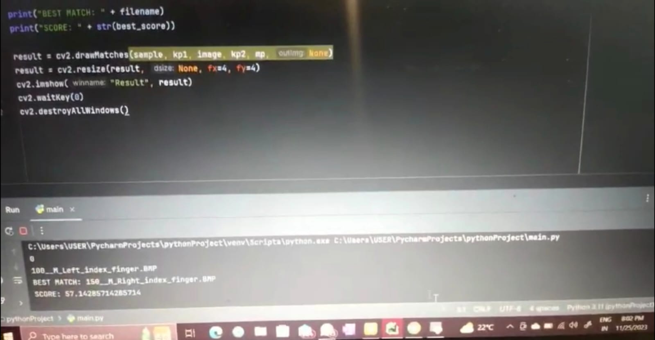

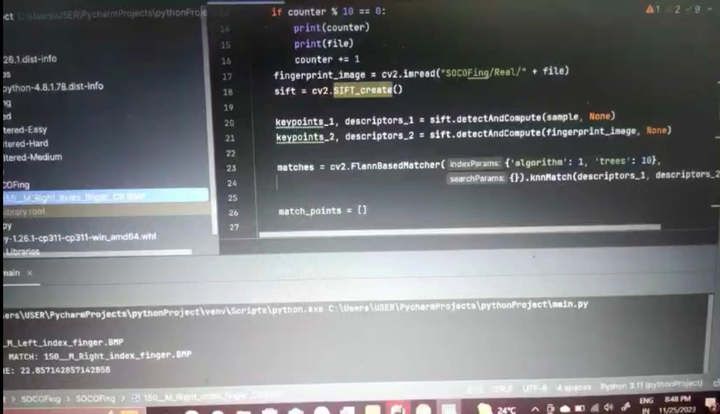

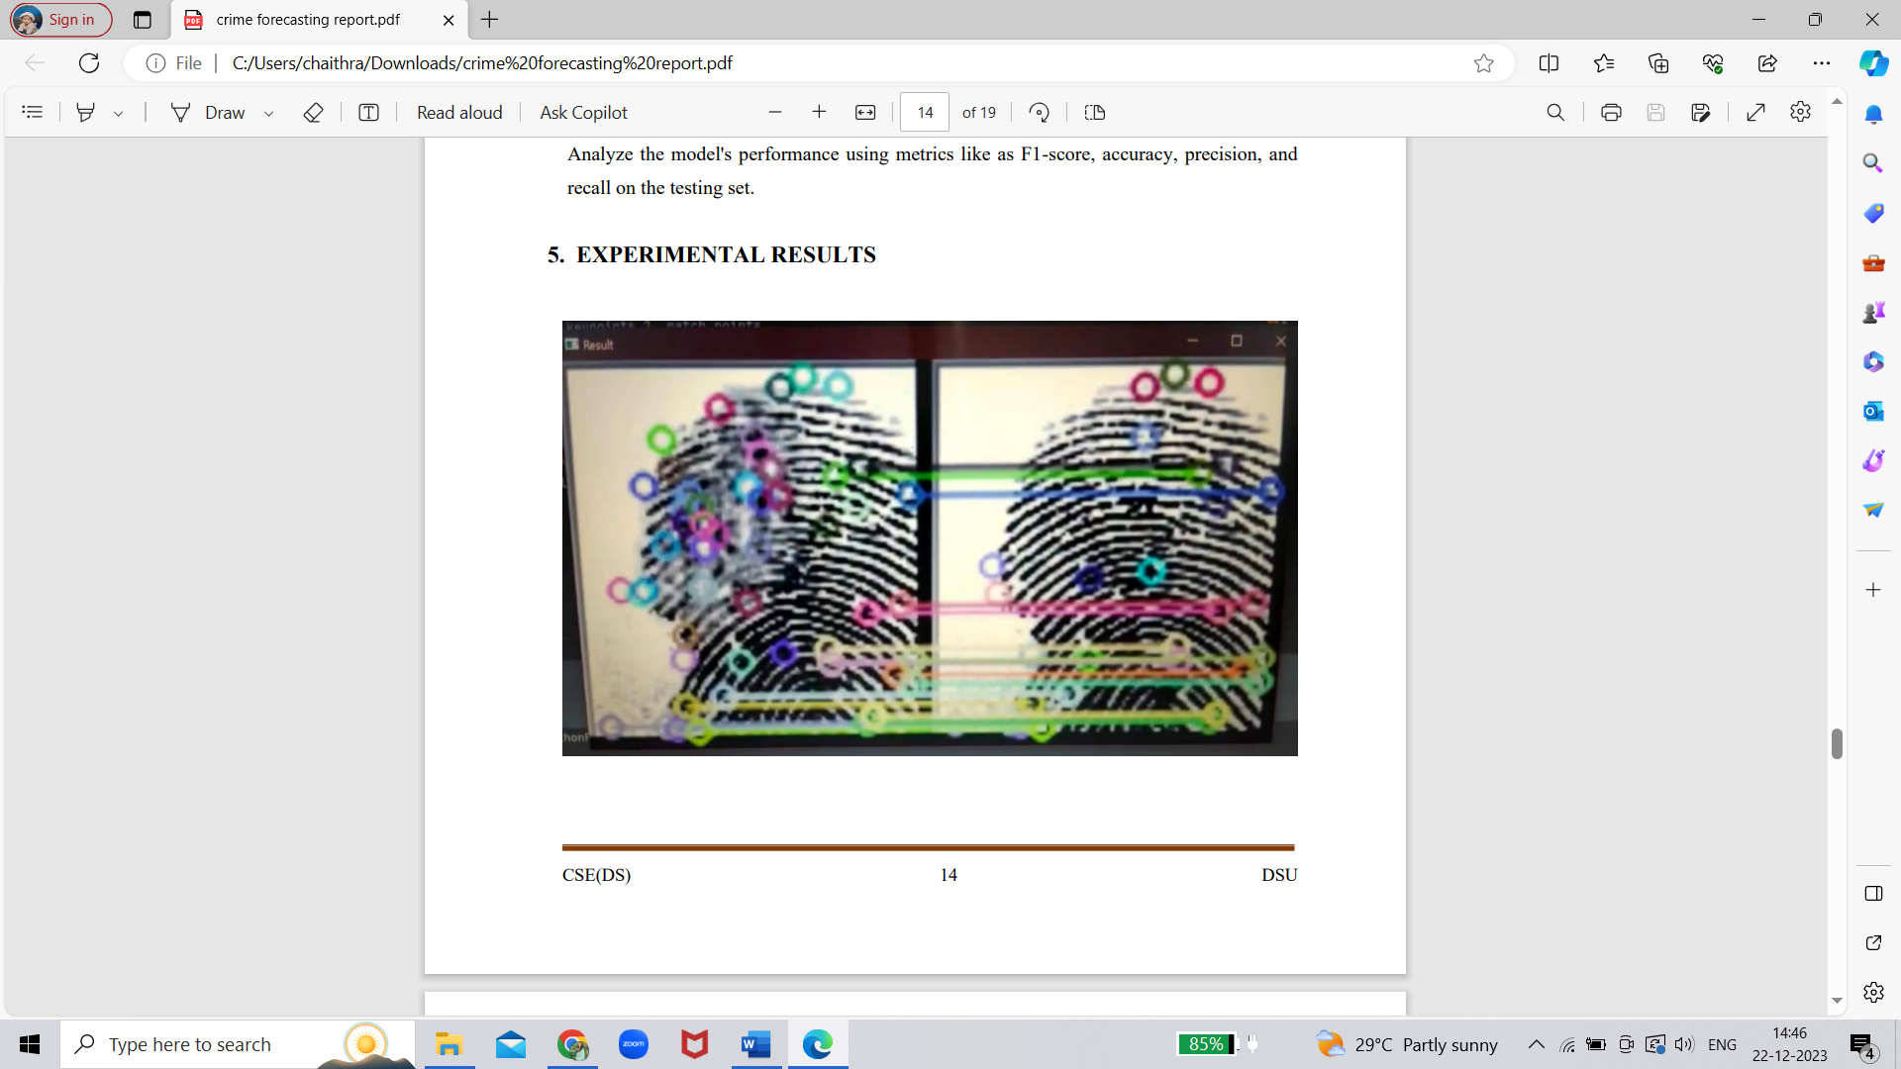

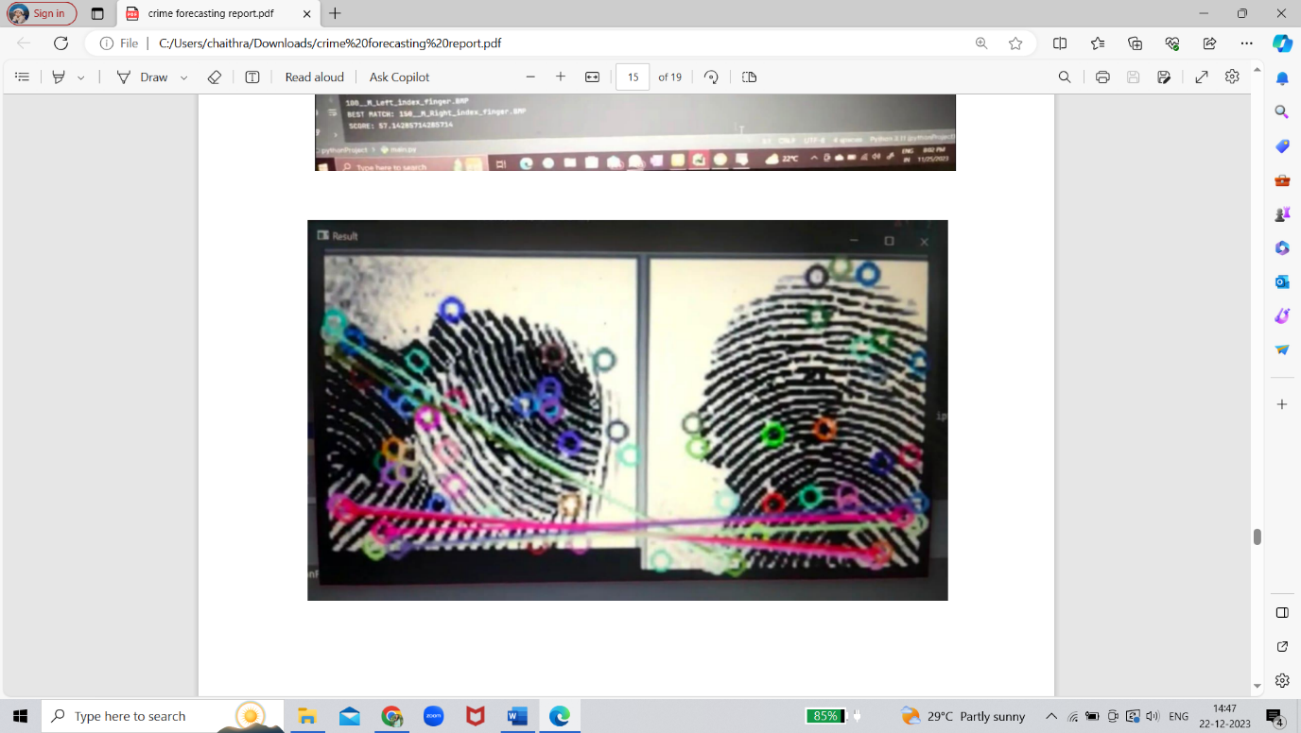

6. CONCLUSION

In conclusion, the integration of computer vision, especially digital fingerprint identification, into crime prediction systems has shown significant progress in improving police capabilities. Using SOKO material helped create training models that can effectively identify and analyze crime scene fingerprints. The main results of this study show that computer vision algorithms used for fingerprint identification can significantly improve the accuracy and efficiency of identifying individuals involved in criminal activity. The SOKO dataset, with its versatile and extensive collection of fingerprints, has played a key role in training models that can handle real-world scenarios. One of the important achievements of this research is faster fingerprint analysis, which helps law enforcement. for agencies making timely and effective decisions. Reduced manual labor associated with fingerprint identification combined with improved accuracy streamlines the investigation process. However, it is important to recognize the ethical considerations involved in the use of such technology. It is necessary to find a balance between public safety and privacy. Policymakers and law enforcement must work together to create clear guidelines and regulations that guide the ethical use of computer vision technology in crime prevention. Continued advances in machine learning, combined with the availability of large and diverse datasets, are likely to lead to more robust and accurate models. In addition, ongoing research and development should focus on addressing potential

biases in algorithms and ensuring transparency in the decision-making processes of these systems, the successful integration of computer vision into crime prediction, especially through digital fingerprint identification using the SOKO dataset, represents significant progress in the use of technology to improve public safety.

7. REFERENCES

1. Overview of Fingerprint Recognition System. Mouad M.H. Ali, Vivek Hilal Mahale, Pravin Yannawar, Ashok Gaikwad. March 2016. Conference: 2016 International Conference on Electrical, Electronics, and Optimization Techniques (ICEEOT) DOI:10.1109/ICEEOT.2016.7754902

2. A new framework for IRIS and fingerprint recognition using SVM classification and extreme learning machine based on score level fusion. S. Sangeetha, N. Radha.

DOI: 10.1109/ISCO.2013.6481145

3. A.K. Jain, S. Prabhakar, L. Hong, S. Pankanti. Filter Bank Based Fingerprint Matching. IEEE Transactions on Image Processing.

DOI: 10.1109/83.841531

4. G. Singhal and S. Chaudhury (2004) Fingerprint Classification Using Gabor Filter and Support Vector Machines. INDICON Proceedings of the IEEE,Initial India Biennial Conference, Kharagpur, December 20–22, 2004; 256-261.

<https://doi.org/10.1109/INDICO.2004.1497751>

5. A Systematic Approach for Feature Extraction in Fingerprint Images, Chikkerur, C.W. and Govindaraju, V. (2004). Hong Kong, 15–17 July 2004: ICBA 2004. <https://doi.org/10.1007/978-3-540-25948-0_48>

6. Fingerprint enhancement by directional Fourier filtering. B.G. Sherlock, D.M. Monro, K. Millard DOI: 10.1049/ip-vis:19949924

7. In 2002, Nilsson, K., and Bigun, J. applied complex filters to fingerprint images in order to identify prominent symmetry points that were used for alignment. In: Biometric Authentication, Springer, Berlin, eds. Tistarelli, M., Bigun, J., and Jain, A.K. <https://doi.org/10.1007/3-540-47917-1_5>